EXPERIMENT – 1
K.YOGANAND(192525173)

STUDENT FORM :
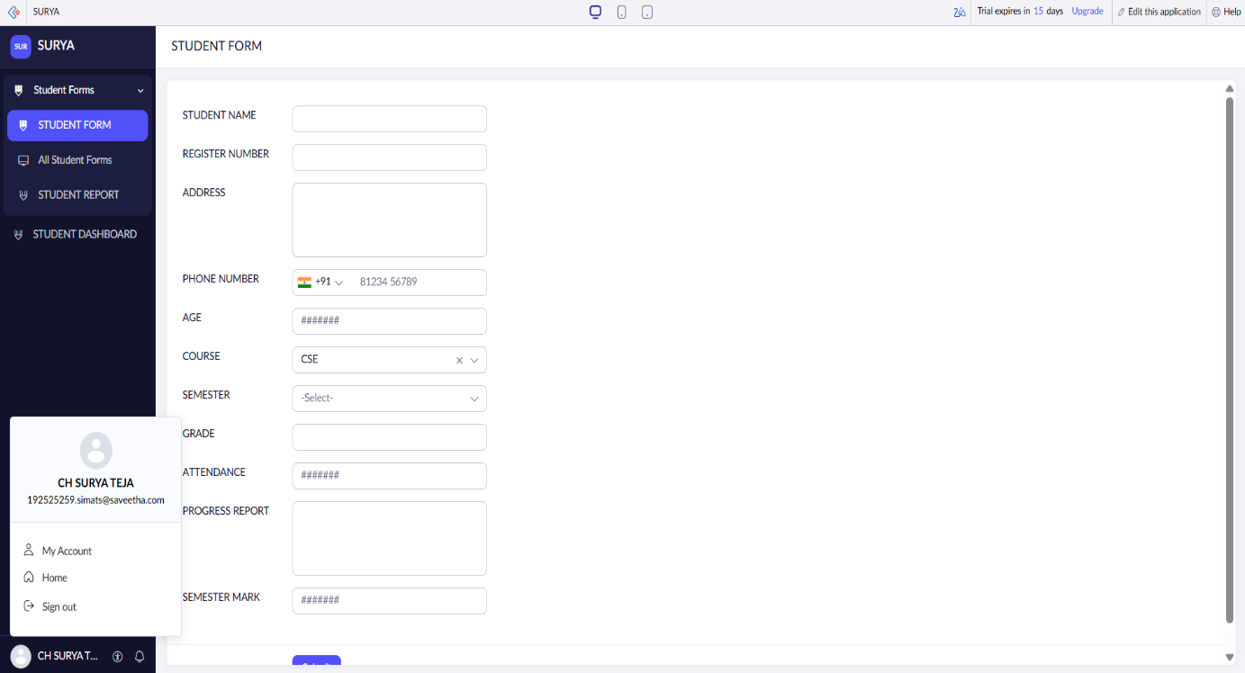
STUDENT REPORT :
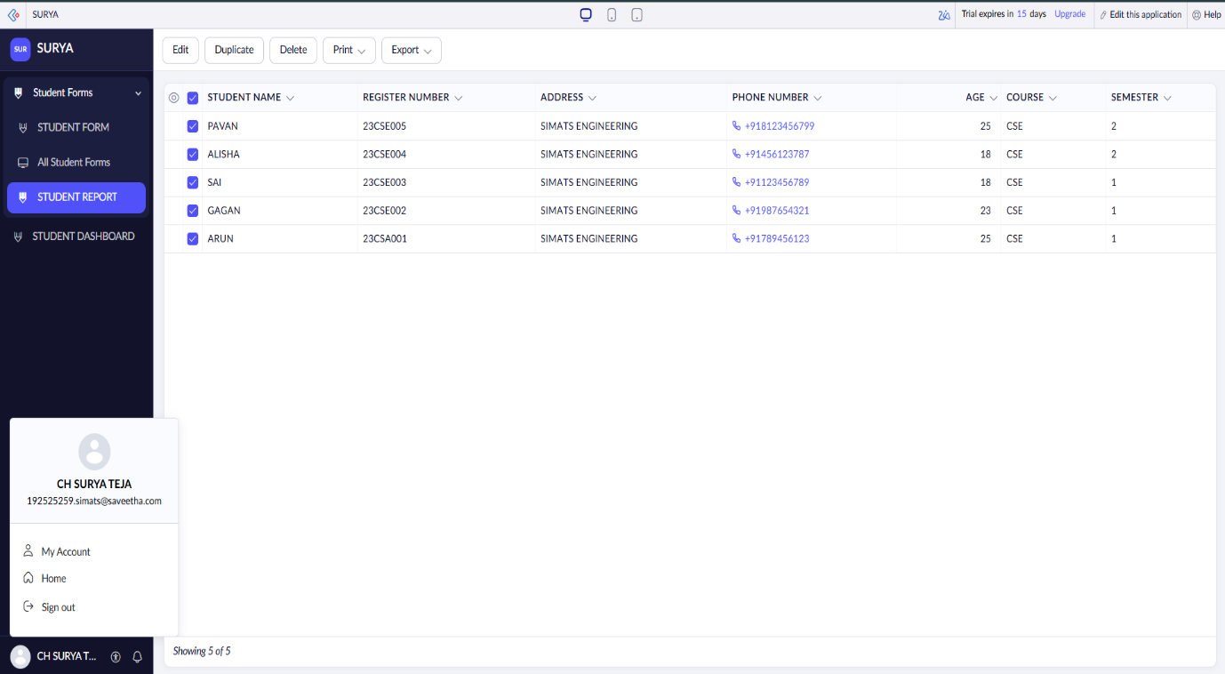

STUDENT DASHBOARD :
